(Approx. 724 words)

Good Computer House Cleaning
By Len Nasman, Editor / Webmaster, Bristol Village Computer Club, OH
March 2017 issue, BVCC newsletter
www.bvres.org
bvclub (at) bvres.org
As you use your computer, some things get a little messy. For example, each time you uninstall or update an application an area of memory called the registry is changed.
When you install some programs, they might add a feature that keeps part of them running in the background. An example might be when you install software for a printer, a background program might be installed that keeps checking printer use and pops up a reminder to order supplies. If you get too many unnecessary things like this running in the background, it will slow down your computer.

Also, whenever you visit websites, they make copies of things and store them in so-called temporary files. The files are called temporary, but they remain there until you remove them.

For example; Internet Explorer saves things in a number of categories. BTW, if you have more than one user that can login to your computer, these files are saved separately for each different user. Each web browser program (Internet Explorer, Chrome, Firefox) maintains a similar list of files.

In any case, it is a good idea from time to time to clean up the registry, stop unnecessary background programs, and remove temporary files. A useful free program to keep your computer tidy is CCleaner. This program has options for taking care of the issues mentioned earlier.

If you have already installed CCleaner, jump to the update section.
Installing CCleaner

When you go to the CCleaner download web page you will see three different versions offered.
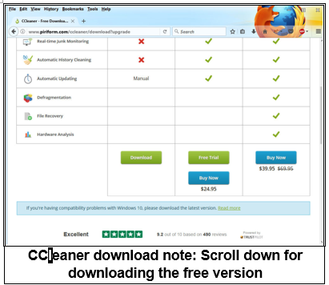
https://www.piriform.com/CCleaner/download

After you select the Download option, a dialog box will pop up that lets you save the install file.

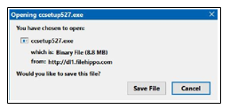

The install program will open an install window that might have a check box that, if not unchecked, will install other software. Watch out for this. Select the Custom install option and select how you would like CCleaner to be installed.

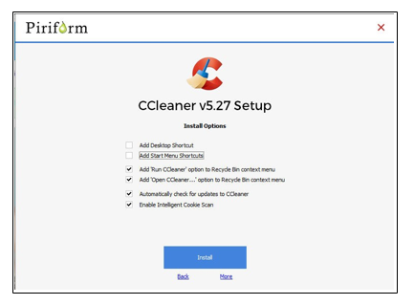

Using CCleaner
There is a vertical list of options on the left side of the CCleaner window. The Cleaner option allows you to toggle different things to be removed. For example, if you do not want to remove Cookies, or browsing History, select the check marks to toggle the options off. Near the top of the window is a button that has a similar list of options for other applications.
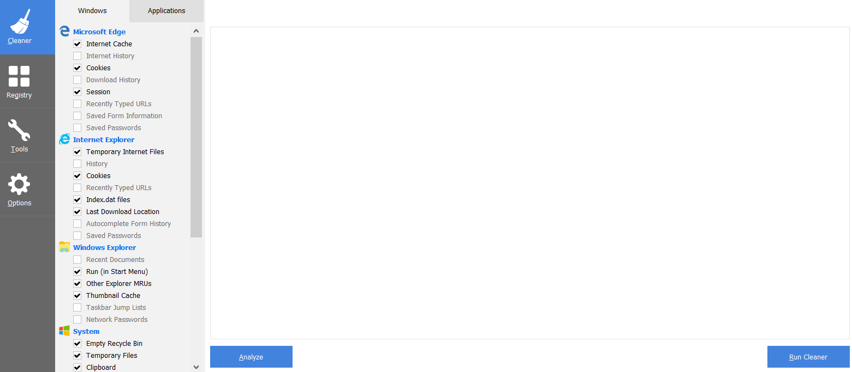

If you select the Analyze button near the bottom of the CCleaner window, the program will go through the motions without deleting any files. It will, however, give you a report of what will be removed if you select the Run Cleaner button.

Cleaning the Registry
When you select the Registry button in CCleaner, you will see two buttons near the bottom of the Window; Scan for Issues and Fix selected issues. After you have scanned for issues, you will see a list of things the system detected. If you then select the Fix selected issues button, you will have the option to backup registry changes. Select yes, and then select Fix All Selected Issues option. It is a good idea to repeat the Scan for Issues option until no issues are found.
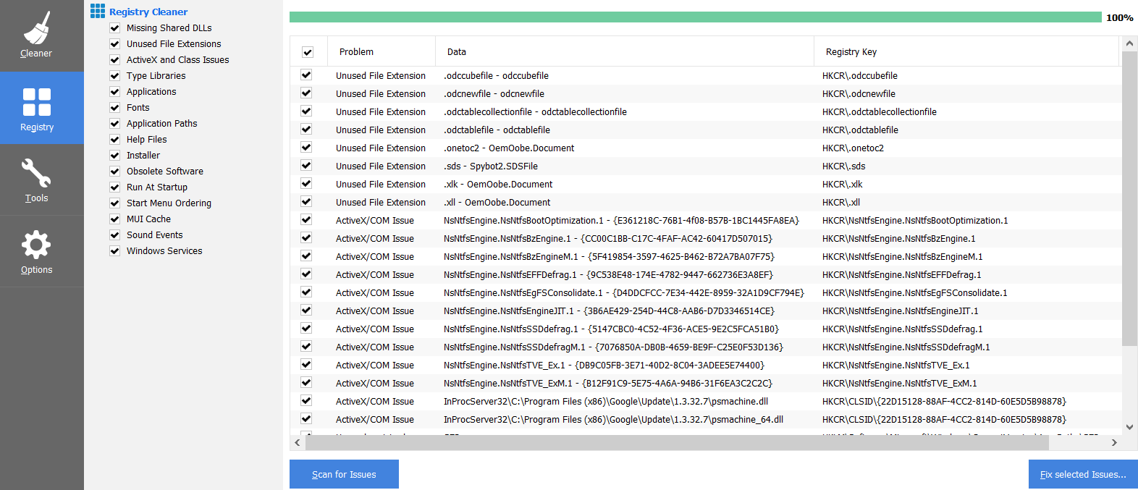

Checking the Startup Programs
CCleaner provides an option to check what programs start running when Windows is first started. In most cases, there are programs that you do not want to always be running in the background.

Select the Tools button in CCleaner, then select the Startup option. Locate a program that you do not want running in the background and right click on Yes, then select Disable. Note that the Disable option does not uninstall the program. It simply removes it from the list of programs that run in the background.
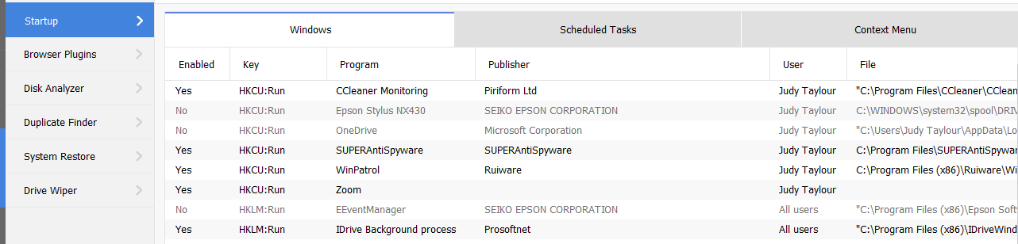

Observe that there is a Tools, Uninstall option that can be used to uninstall programs. It can also sometimes be used to repair programs that have developed problems.
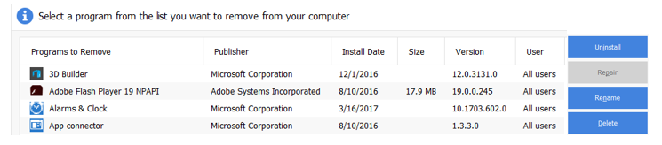

Updating CCleaner
From time to time CCleaner will tell you that an update is available. When you go to the update web page be careful. It will offer an upgrade option. Note that the upgrade option costs money, while there is a free version for updating. Scroll down the page to find the free update. See the download note in an earlier illustration.

